Launching the Watson French Environmental, Social & Governance Policy

A recent team meeting at Watson French focussed on the many ways in which we can minimise the impact of our business on the environment – a subject which all of our team feel strongly about and one which is of increasing local, and global, importance.

This conversation resulted in a wealth of ideas, covering the obvious – such as offsetting travel and minimising paper use – to the more imaginative, like being advocates for ethical investing and encouraging employees to take up voluntary roles with local charities.

We have now decided to firmly commit to these ideas, and have formalised our good intentions in the new Watson French Environmental, Social & Governance Policy.

As part of this policy, and to assess progress towards our environmental aims (as Chartered Financial Planners, we do like to keep our plans under ongoing review!) we have decided as a company to measure our Carbon Footprint annually.

This was a hugely interesting and illuminating exercise, and the results are illustrated neatly by the following chart:

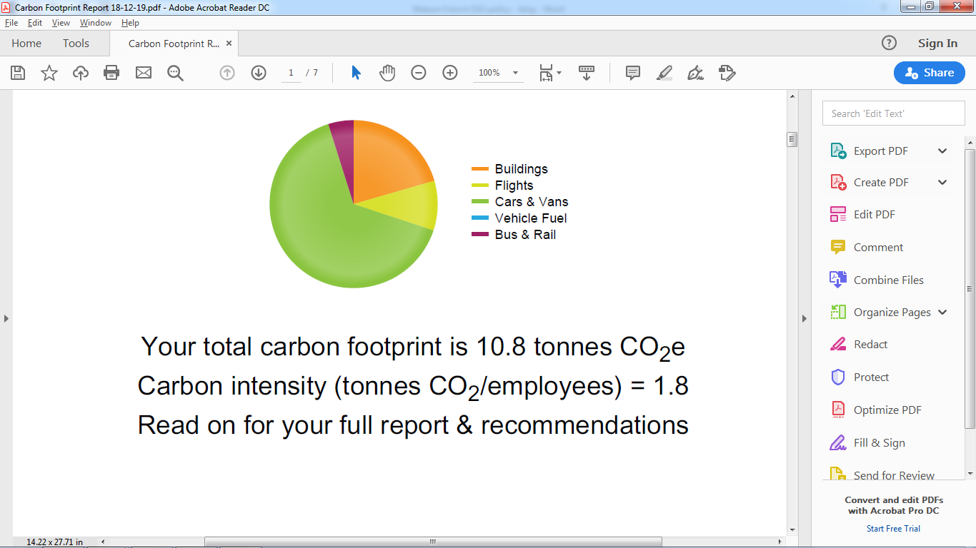

*Source: Carbonfootprint.com Report*

As we expected, travel makes up the majority of our Carbon Footprint and we aim to take steps to reduce this aspect of our impact on the environment immediately.

In conjunction with a local charity, we have also committed to plant trees each year to offset any Carbon emissions we cannot otherwise mitigate.

We look forward to implementing and embodying our new Environmental, Social & Governance Policy and hope to report the positive effects it will have in future.